Book Suggestions for Senior Leaders
By Perry Holley, Executive Coach

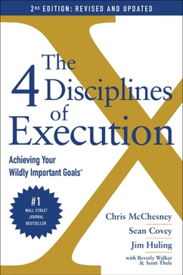 | The 4 Disciplines of Execution: Revised and Updated: Achieving Your Wildly Important Goals  Chris McChesney, Sean Covey, Jim Huling, Scott Thele, and Beverly Walker
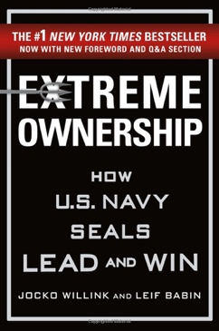 | Extreme Ownership  Jocko Willink
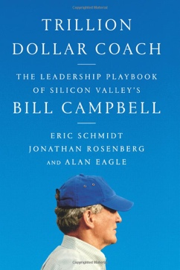 | Trillion Dollar Coach: The Leadership Playbook of Silicon Valley’s Bill Campbell  Eric Schmidt, Jonathan Rosenberg, and Alan Eagle
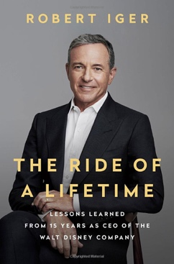 | The Ride of a Lifetime: Lessons Learned from 15 Years as CEO of the Walt Disney Company  Robert Iger
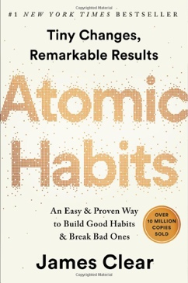 | Atomic Habits: An Easy & Proven Way to Build Good Habits & Break Bad Ones  James Clear
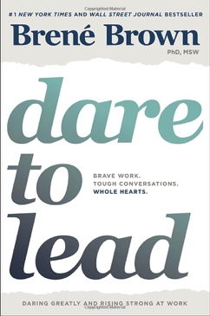 | Dare to Lead: Brave Work. Tough Conversations. Whole Hearts.  Brené Brown
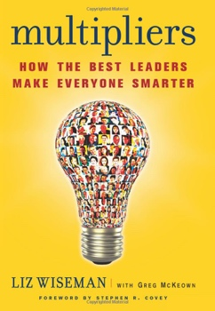 | Multipliers, Revised and Updated: How the Best Leaders Make Everyone Smarter  Liz Wiseman & Greg McKeown
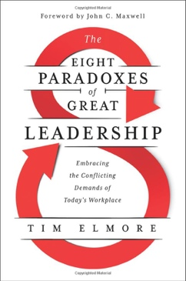 | The Eight Paradoxes of Great Leadership: Embracing the Conflicting Demands of Today’s Workplace  Tim Elmore
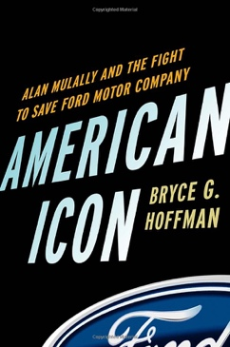 | American Icon: Alan Mulally and the Fight to Save Ford Motor Company  Bryce G. Hoffman
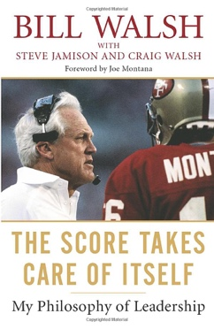 | The Score Takes Care of Itself: My Philosophy of Leadership  Bill Walsh
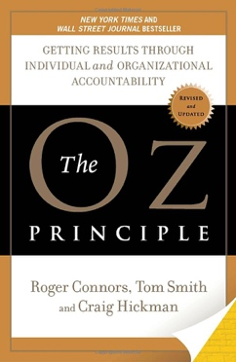 | The Oz Principle: Getting Results Through Individual and Organizational Accountability  Roger Connors, Tom Smith, and Craig Hickman
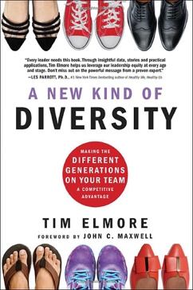 | A New Kind of Diversity: Making the Different Generations on Your Team a Competitive Advantage  Tim Elmore
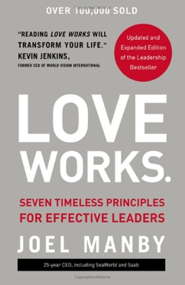 | Love Works: Seven Timeless Principles for Effective Leaders  Joel Manby
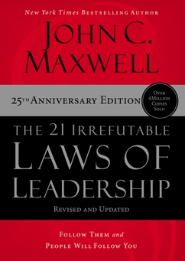 | The 21 Irrefutable Laws of Leadership: Follow Them and People Will Follow You (25th Anniversary Version)  John C. Maxwell
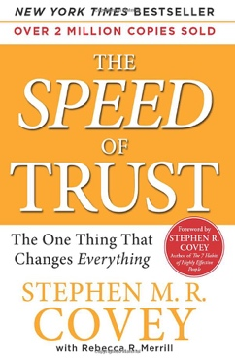 | The SPEED of Trust: The One Thing That Changes Everything  Stephen M. R. Covey
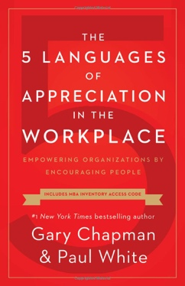 | The 5 Languages of Appreciation in the Workplace: Empowering Organizations by Encouraging People  Gary Chapman
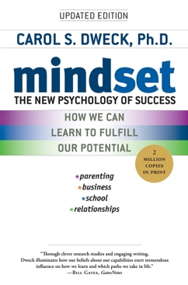 | Mindset: The New Psychology of Success  Carol S. Dweck
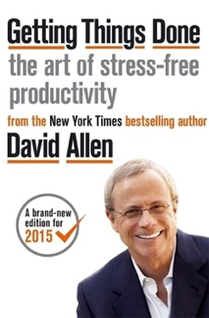 | Getting Things Done  David Allen
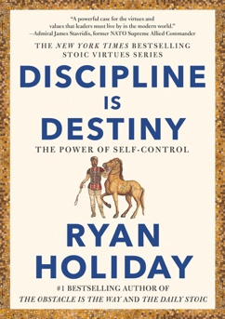 | Discipline is Destiny  Ryan Holiday
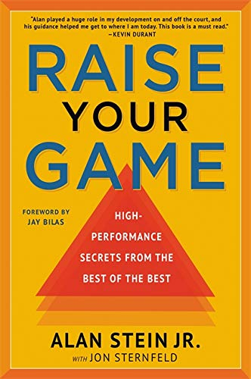 | Raise Your Game  Alan Stein
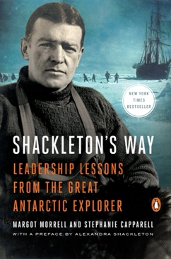 | Shackleton’s Way: Leadership Lessons from the Great Antarctic Explorer  Margot Morrell and Stephanie Capparell
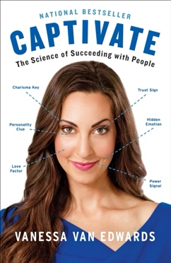 | Captivate Deluxe: The Science of Succeeding with People  Vanessa Van Edwards

